MOSFET HW 1 (18 points)
(jas, MOSFET HW 1.docx, 11/18/2025)

Clearly indicate answers and include units for numeric answers, using 3 or 4 significant figures. Show at least the major steps of your work so that if necessary partial credit can be awarded.
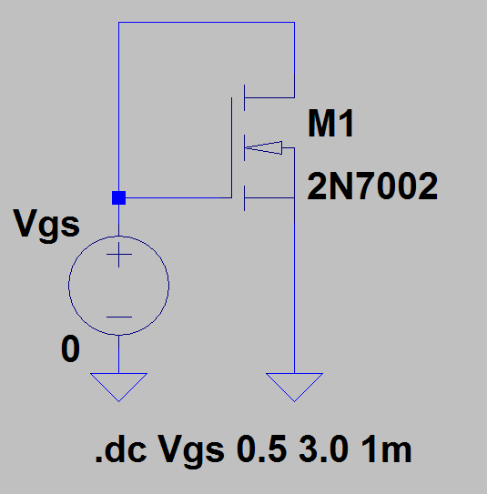
- Use LTspice to characterize the 2N7002 n-channel enhancement mode MOSFET with a V_{GS} voltage sweep as illustrated in the adjacent schematic.
Connect up the adjacent circuit in LTspice by placing an NMOS transistor. Next change the NMOS value to 2N7002, simply by changing the text, which will associate this MOSFET with the 2N7002 model available in the LTspice pick list. You can also hover the mouse over the MOSFET symbol, click on the Pick New MOSFET button and choose the 2N7002 MOSFET from Fairchild, located below the RJK0651DPB from Renesas near the bottom of the pick list, although it may be hard to find. Utilize the DC Sweep analysis as indicated in the schematic, then after running the sweep in the Waveform Viewer attach a cursor to the Id(M1) trace and adjust the vertical cursor scale as close to 1 mA as possible. For the 2N7002, the threshold voltage V_{T} is defined as the gate-to-source voltage required to achieve a drain current magnitude of 250 µA, which according to the data sheet varies between 1 and 2.5 V. For documentation purposes, drag the cursor box indicating V_{GS} corresponding to I_{d} ≈ 250 µA onto the plot pane. Because of simulation resolution, the drain current will not exactly equal 250 µA, so simply adjust the waveform cursor as close as possible. Also, annotate your plot pane with your name by means of the Plot Settings → Notes and Annotations → Place Text options available by accessing the Plot Settings pulldown menu above the toolbar. Replace the plot below with your own version. (5 Points.)
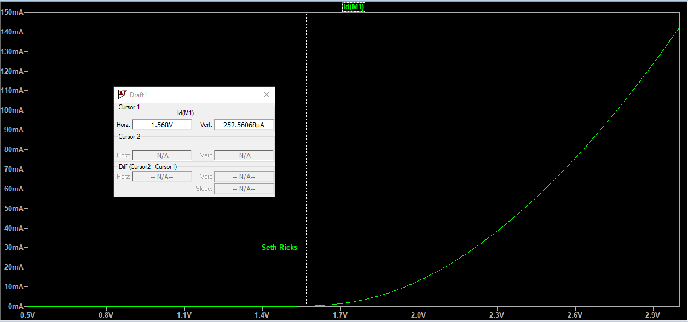

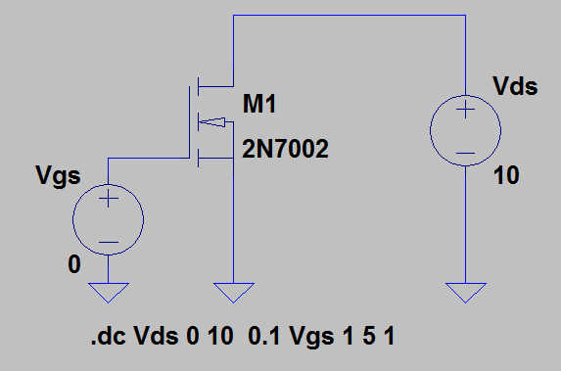
- Use LTspice to generate a family of I_{D} curves for a V_{DS} sweep at various V_{GS} values for the 2N7002 n-channel enhancement mode MOSFET by connecting up the adjacent circuit. Utilize the DC Sweep analysis, with two sources as indicated by .dc Vds 0 10 0.1 Vgs 1 5 1 in the adjacent schematic. Annotate your plot pane with your name by means of the Plot Settings → Notes and Annotations → Place Text options available by accessing the Plot Settings pulldown menu above the toolbar. Replace the family of Id(M1) versus Vds curves below with your own version. (4 Points.)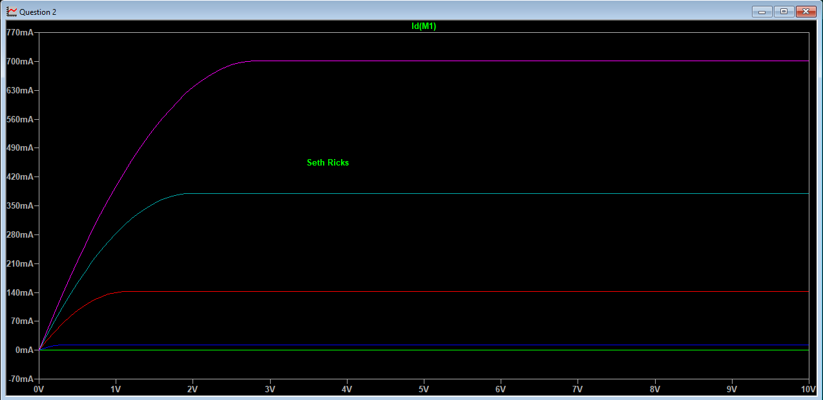

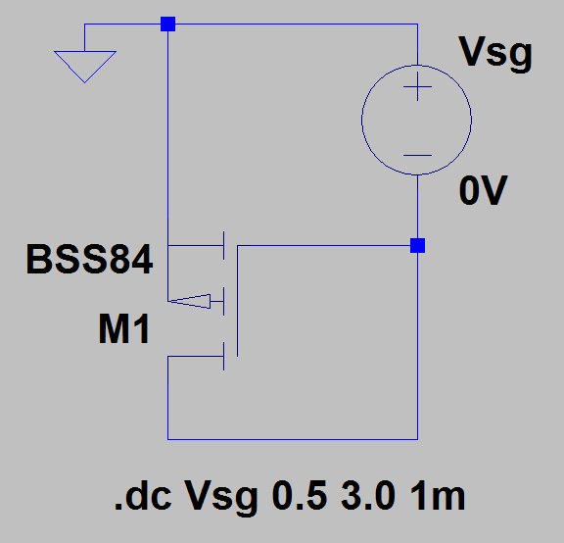
- Use LTspice to characterize the BSS84 p-channel enhancement mode MOSFET with a V_{SG} voltage sweep as illustrated in the adjacent schematic.
Connect up the adjacent circuit in LTspice by placing a PMOS transistor. Next change the PMOS value to BSS84, simply by changing the text, which will associate this MOSFET with the BSS84 model available in the LTspice pick list. You can also hover the mouse over the MOSFET symbol, click on the Pick New MOSFET button and choose BSS84 MOSFET from NXP, located near the top of the pick list. Utilize the DC Sweep analysis as indicated in the schematic, then after running the sweep in the Waveform Viewer attach a cursor to the Id(M1) trace and adjust the vertical cursor scale as close to -1 mA as possible. For many discrete MOSFETs, including the BSS84, the threshold voltage V_{T} is defined as the gate-to-source voltage required to achieve a drain current magnitude of 1 mA. Hence, the gate-to-source voltage associated with a drain current of -1 mA equals the threshold voltage of the BSS84, which is a negative number for a p-channel enhancement mode MOSFET. However, since the dc sweep shown above uses V_{SG} instead of V_{GS} the V_{SG} voltage value associated with I_{d} = -1.0 mA is a positive number that is |V_{T}| for the BSS84 rather than V_{T}, so expect a positive number for your simulated value of V_{SG} corresponding to I_{d} = -1.0 mA. For documentation purposes, drag the cursor box indicating V_{SG} corresponding to I_{d} = -1.0 mA onto the plot pane. Also, annotate your plot pane with your name by means of the Plot Settings → Notes and Annotations → Place Text options available by accessing the Plot Settings pulldown menu above the toolbar. Replace the plot below with your own version. (5 Points.)
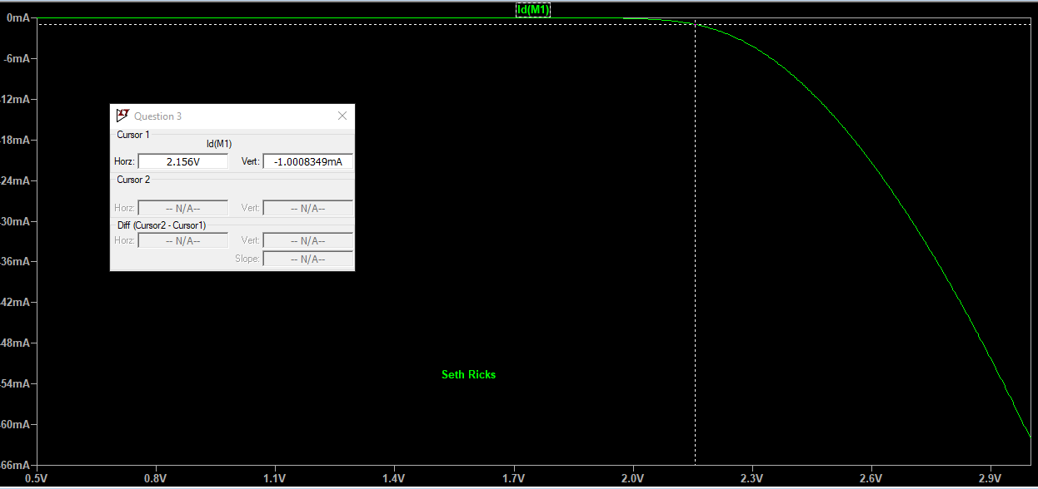

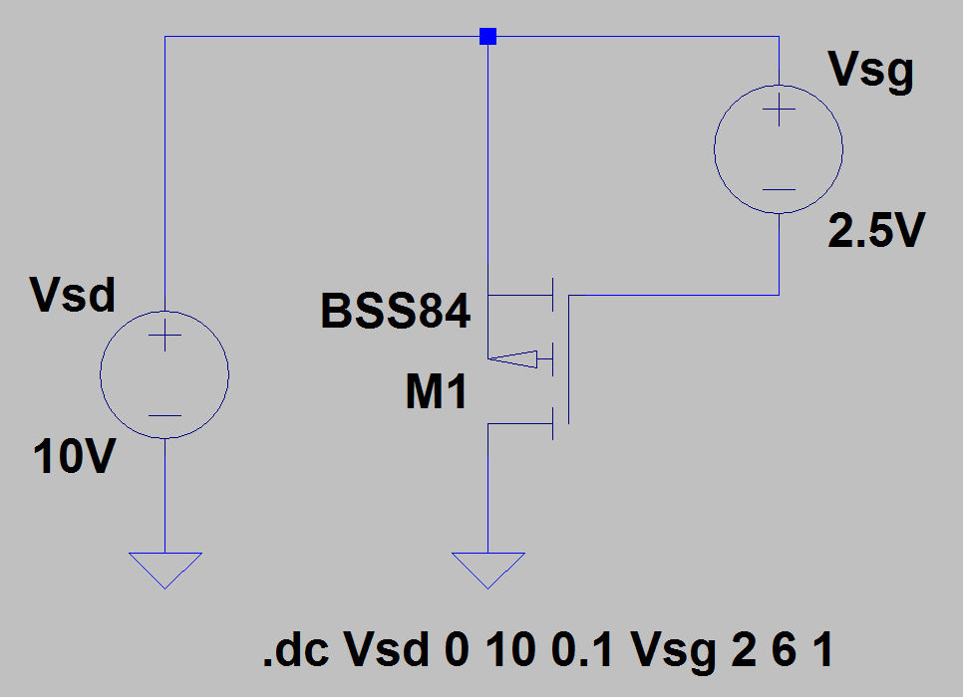
- Use LTspice to generate a family of I_{D} curves for a V_{SD} sweep at various V_{SG} values for the BSS84 p-channel enhancement mode MOSFET by connecting up the adjacent circuit. Utilize the DC Sweep analysis, with two sources as indicated by .dc Vsd 0 10 0.1 Vsg 2 6 1 in the adjacent schematic. Annotate your plot pane with your name by means of the Plot Settings → Notes and Annotations → Place Text options available by accessing the Plot Settings pulldown menu above the toolbar. Replace the family of Id(M1) versus Vsd curves below with your own version. (4 Points.)
